List of Requirements

# Introduction

A company owns a warehouse, and they want an administration system to be developed in order to keep track of the products they ship and receive. Currently there are three different roles in the warehouse which should be taken in mind when designing the application:

1. Manager- A person who has access to everything and is in a higher position than other employees
2. Shipping and receiving specialist (SR specialist)- A person who handles the process of accepting shipping requests, restocking, and notifying background workers about their tasks.
3. Material handler- A person who works in the background, for example doing a task received from a SR specialist or moving products around the warehouse.

# Functional Requirements

* **FR-01: System should be able to store information about products**

*All of the following must be stored: Name of product, length, height, weight, price, number in stock, number shipped, last restock date, category, location in warehouse*

* **FR-02: All employees should be able to search through all products in stock**
* **FR-03: All employees should be able to search for a product with their chosen filters**
* **FR-04: SR specialists should be able create preparation tasks based on shipping requests they are receiving**
* **FR-05: SR specialists should be able to restock a product**
* **FR-06: SR specialists should be able to register new products to the system**
* **FR-07: SR specialists should be able to send preparation tasks to material handlers**
* **FR-08: Material handlers should be able to receive preparation tasks from SR specialists**
* **FR-09: Material handlers should be able to mark preparation tasks as complete, resulting in marking the product which was prepared as sold**
* **FR-10: Managers should be able to operate in all fields of the program**
* **FR-11: All employees should be able to log in**

# Non-Functional Requirements

* **Software should be Simplified- User friendly.**
* **Software should be easily maintainable.**
* **Software should be extendable**

# Wireframe

Login screen:

The login screen will require a username and a password only.

Once system has authorized the user, he/she will be redirected to the main menu screen.



Product search:

This page will display a list of products, which a user can search for and filter them by their category. A user will be able to select a product and open its overview.

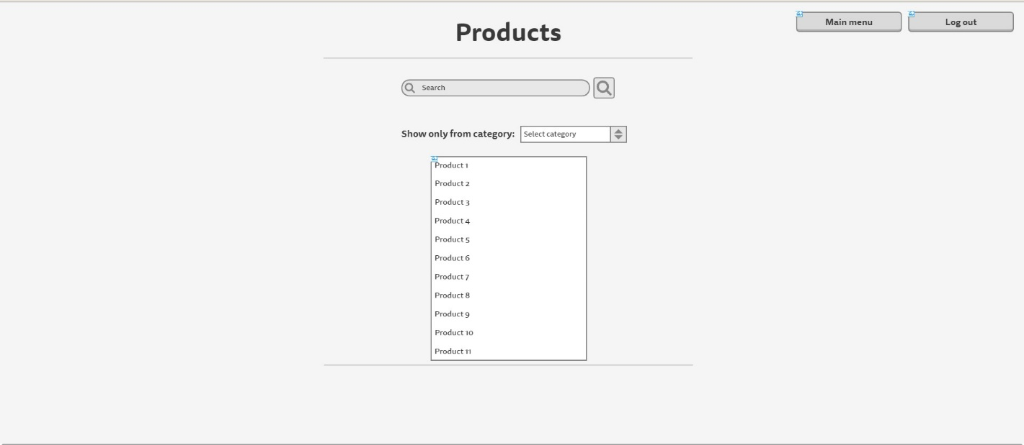

Product overview:

The product overview page will display all information which is stored in the database about the selected product(this includes name, category, size, weight, price, number in stock, location of the product in the warehouse, a number of the times the product is shipped, a display of the most recent product restocks)

The page will also contain a link for restocking the product, which will be viewable only by users with the role “Manager” or “SR specialist”.

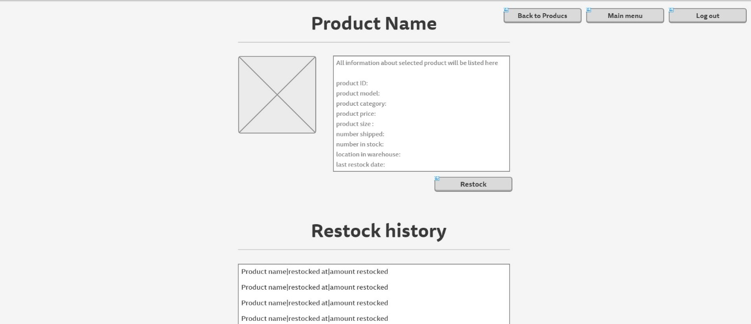

Restock product:

From this page a user with the “SR specialist” role will be able to restock a product.

The product id will be filled in by the system and the user only needs to provide the amount restocked and his password in order to authorize the process.

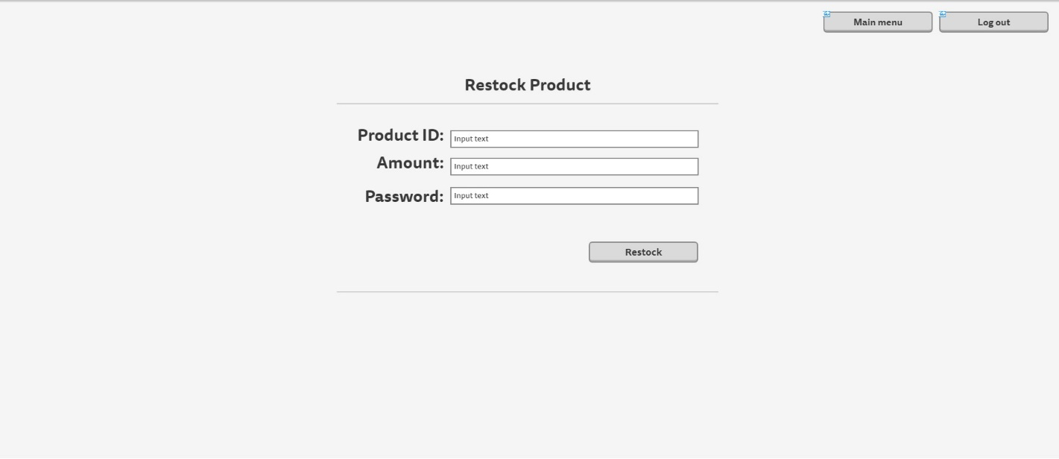

List of pending preparation tasks:

This page will contain a list of preparation tasks which are already issued and are incomplete. A user will be able to select them in order to preview them and if their role is “Material handler” they will be able to mark them as complete.

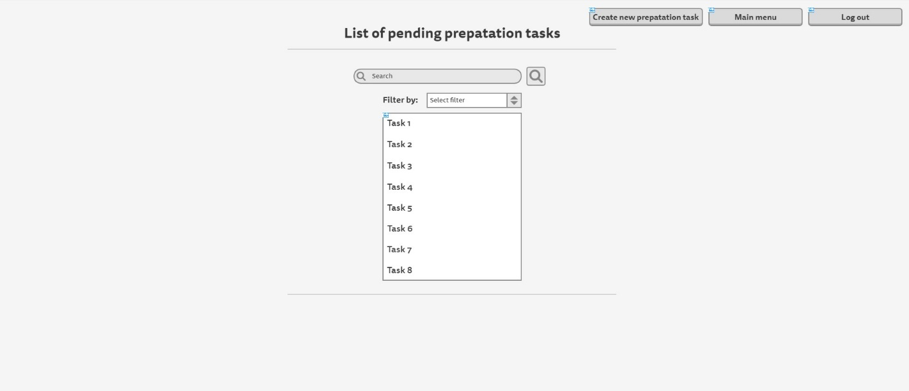

Creating a new preparation task:

This page will allow a user with the needed role to create a preparation task. He/she will be able to specify what needs to be done and until when. Once created the system will provide feedback informing the user whether a task has been successfully created and will show a quick preview of it.

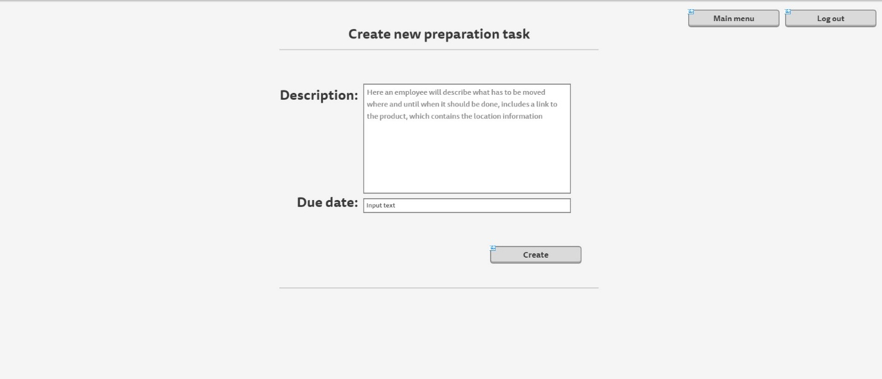

Task overview page:

From this page a user will be able to preview the details of a preparation task.

Users with the role “Material handler” will be able to complete those tasks and by doing so the tasks won’t be show in the list of pending prep tasks anymore.

